AI WEATHERWISE

Project Documentation
- Project Title: Ai weatherwise
- Team ID: SWTID-2026-4781
- Team Leader: Amrin.R & ammuamrin2005@gmail.com
  - Team Members: Neeraja.G & neerajagovardhanagiri@gmail.com
- Team Members: Tamilarasi.G & tamilarasi7204@gmail.com
  - Team Members: Shrileka.R & shrilekaravi2006@gmail.com

1.INTRODUCTION
AI WeatherWise is an intelligent weather information and recommendation system designed to provide users with real-time weather information and AI-powered insights. The system combines weather data with artificial intelligence to generate simple weather summaries and useful recommendations for users. Traditional weather applications mainly display information such as temperature, humidity, and weather conditions. Users may find it difficult to understand these values and decide what activities or precautions are suitable. AI WeatherWise solves this problem by using Google Gemini AI to convert weather information into easy-to-understand summaries and personalized recommendations. The system allows users to securely register and log in to the application and manage their favorite locations. Users can save multiple cities and retrieve weather information whenever required. MongoDB is used to store user and location data, while Mongoose manages the database structures. Security is an important feature of the system. JWT authentication is used to verify users and protect restricted API resources. bcrypt is used for secure password hashing. The backend also includes middleware for authentication, authorization, validation, and request sanitization to improve system security. AI WeatherWise follows a modular MVC architecture, which separates the Model, Controller, and API routing responsibilities. This improves the organization, maintainability, and scalability of the application. Overall, AI WeatherWise combines real-time weather data, secure user management, database storage, and Google Gemini AI to make weather information easier to understand and more useful for everyday decision-making. Overall, AI WeatherWise provides a centralized platform for accessing weather information and receiving intelligent weather-based recommendations. By integrating real-time weather data, Google Gemini AI, MongoDB, secure authentication, and a modular backend architecture, the system aims to provide users with a convenient and reliable way to understand weather conditions. The application can help users make better everyday decisions by presenting complex weather information in a simple and meaningful form.
2.Source Code
**Main technologies used:**
* Node.js
* Express.js
* MongoDB
* Mongoose
* JWT Authentication
* bcryptjs
* Google Gemini AI
* dotenv
* CORS
**Project setup:**
```bash
npm init -y
npm install express mongoose bcryptjs jsonwebtoken cors dotenv multer @google/genai
npm install --save-dev nodemon
```
**Environment variables:**
```env
PORT=5001
MONGO_URI= mongodb://localhost:27017/weatherwise
JWT_SECRET= your_super_secret_jwt_key_123451
GEMINI_API_KEY= AQ.Ab8RN6172wb1eZkOp6Z1173bPxG33219TwvFQ9MB2MU_ohsmig
SCREENSHOT :
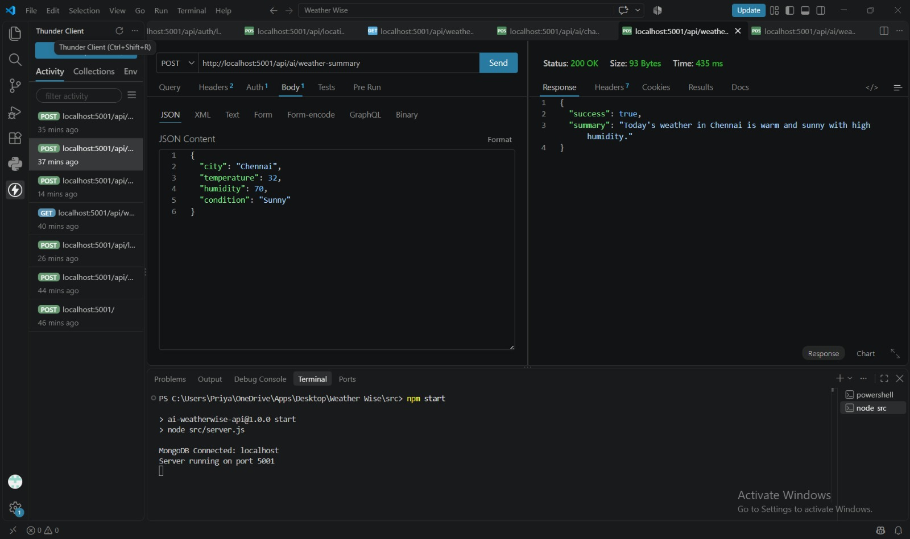
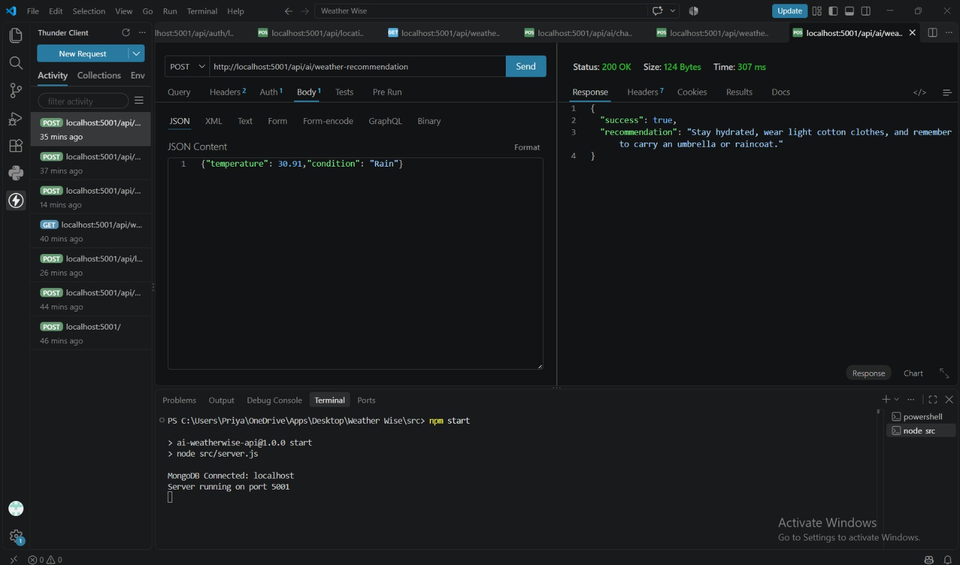
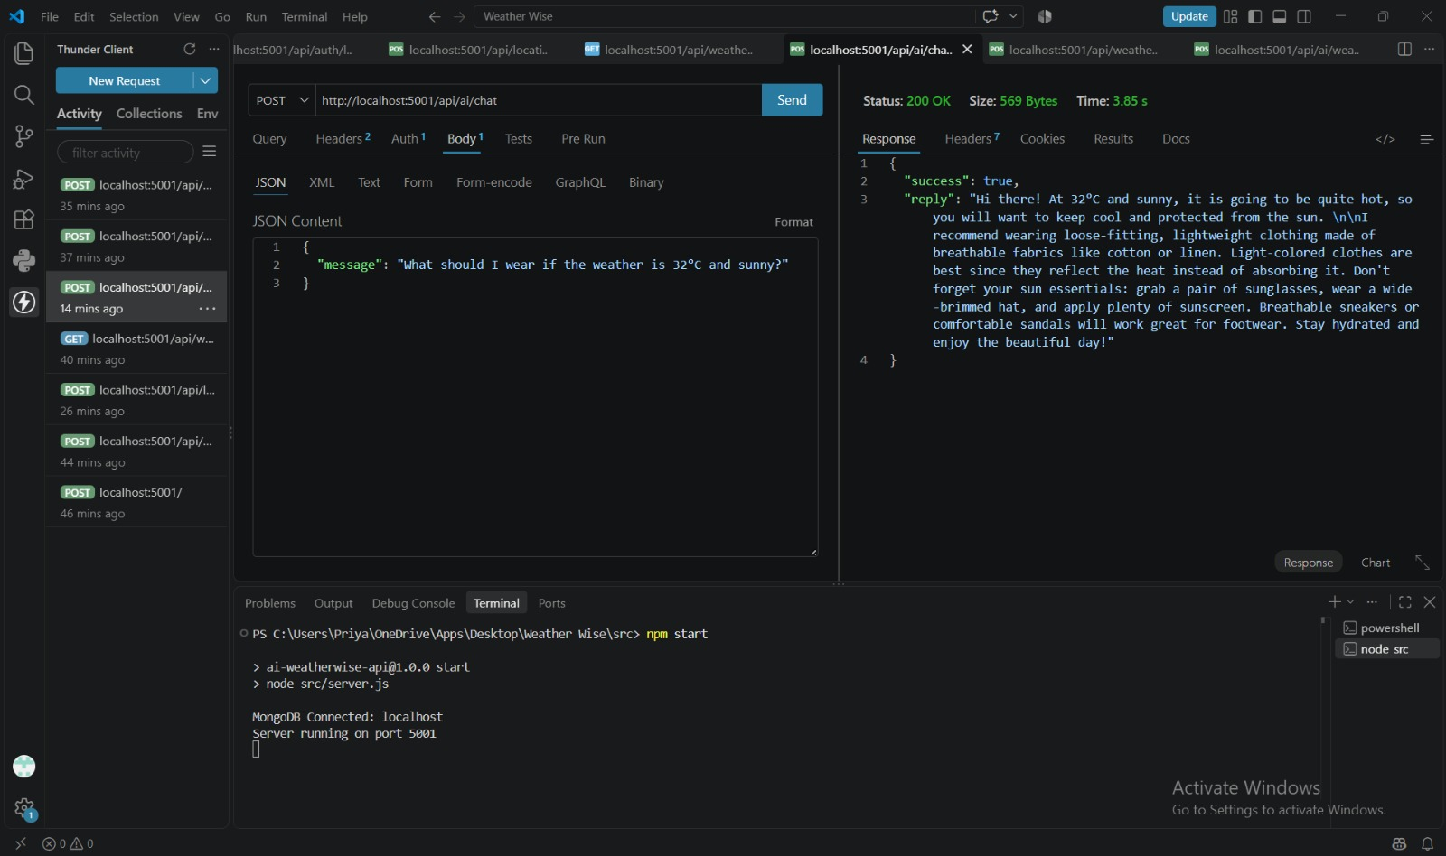
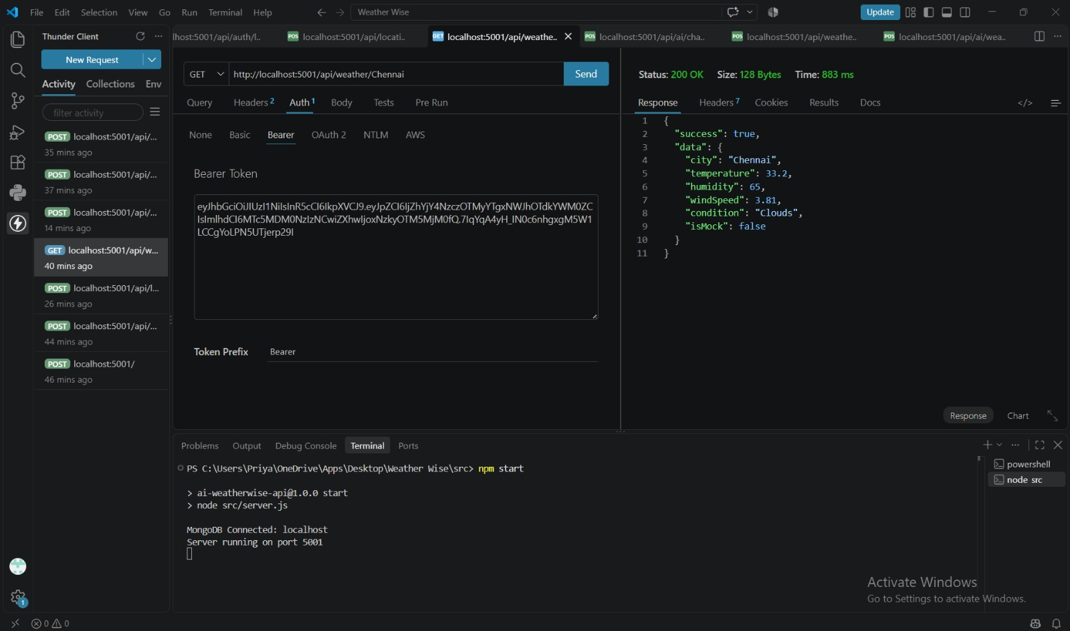
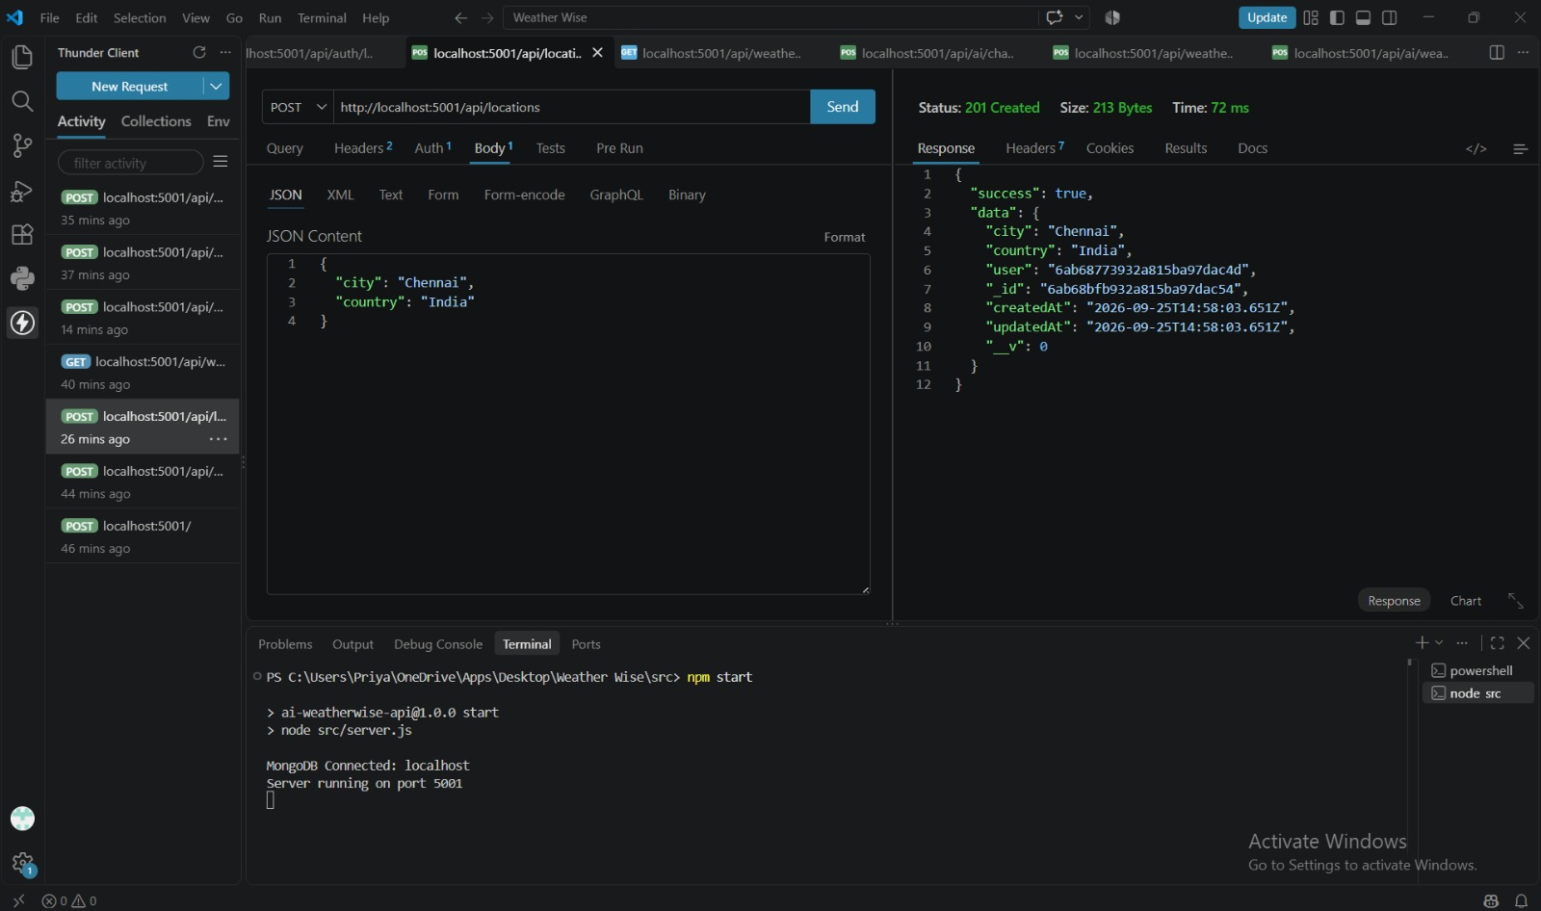
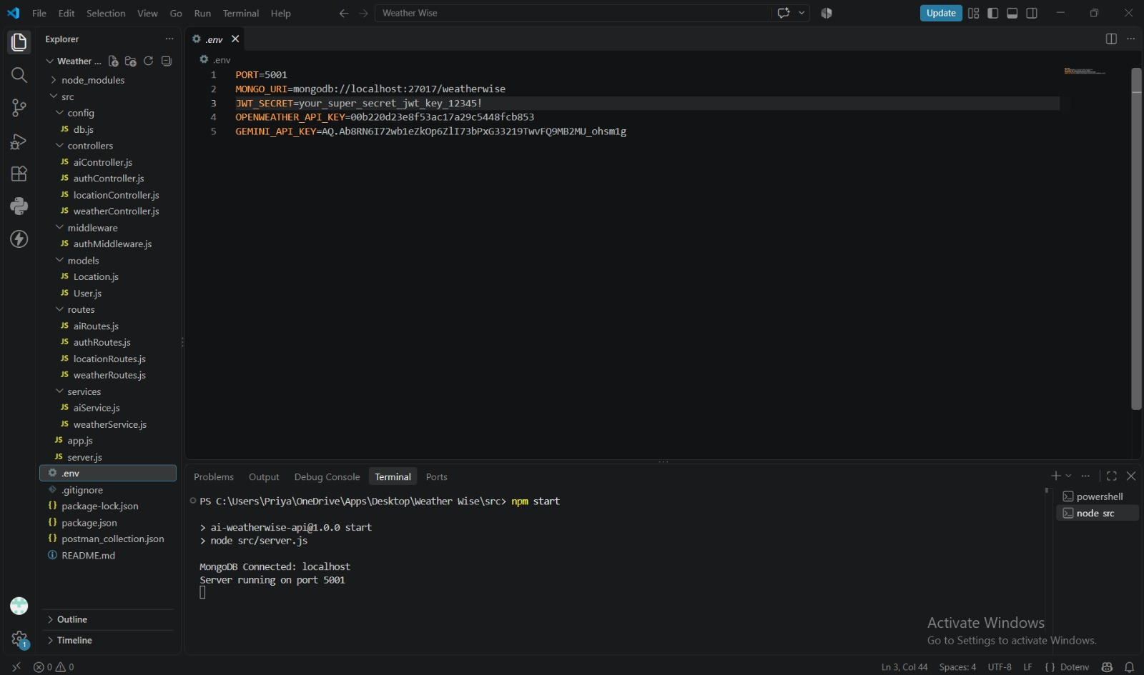
DEMO LINK
https://drive.google.com/drive/folders/1nfvJlPfztNLQT-O1U5INKtYD6y3O81UN

